Windows Scheduler : For Auto Execution of EXE files

Need to execute a specific program on a daily basis for a specific time.

basis by using BAT file.

Steps to run BAT using Windows Scheduler.

**a)** Navigate to Start >> Control Panel >> Administrative Tools >> Task Scheduler  
**b)** Click on Task Scheduler >> Create Task option

[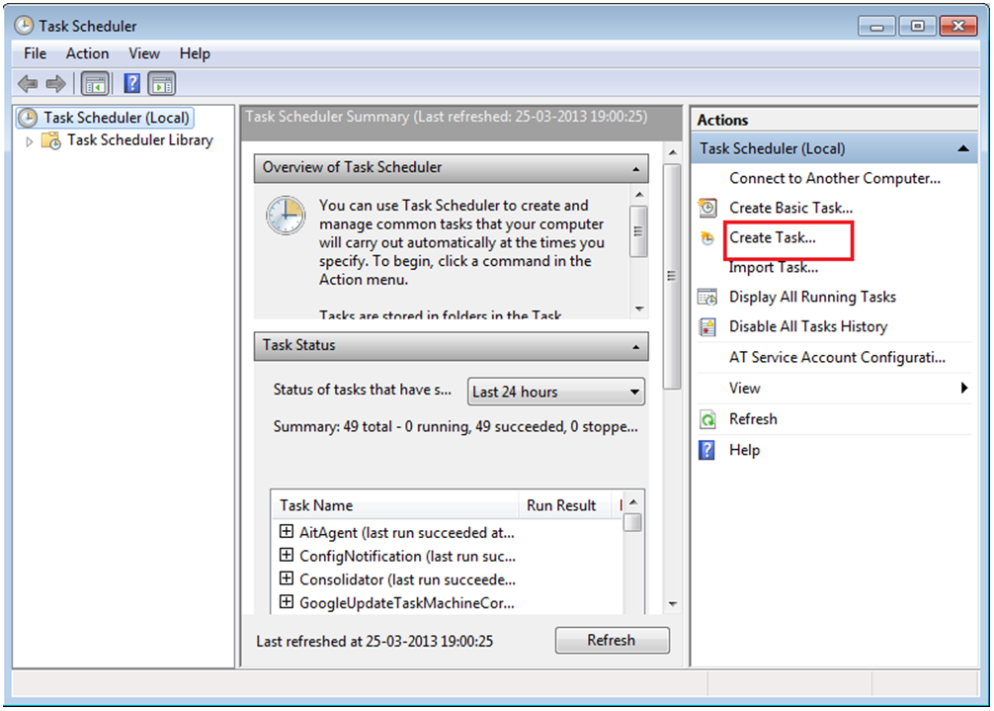](http://www.greytrix.com/blogs/sageaccpacerp/wp-content/uploads/2013/08/1.-Task-Scheduler.png)

**c)** ‘Create Task’ UI will open.  In General Tab, Enter the Task Name.

[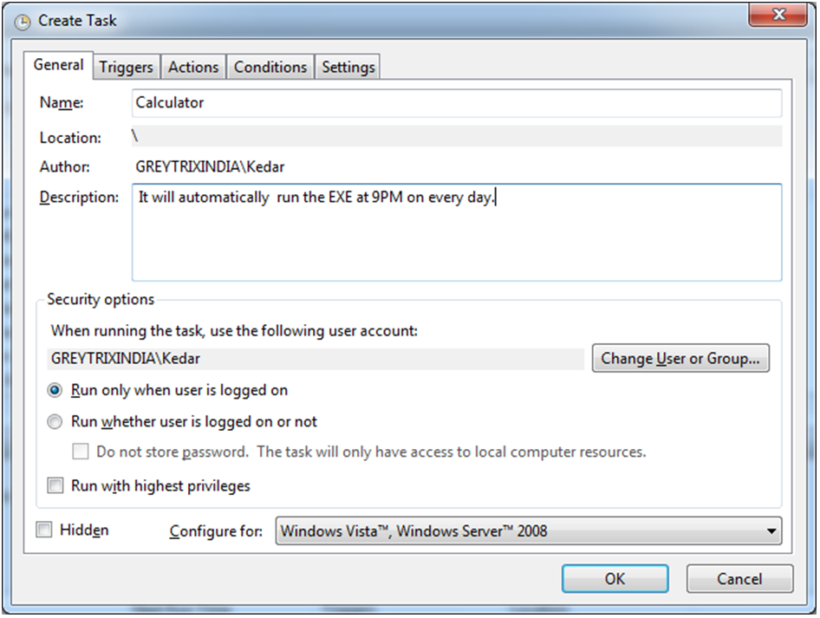](http://www.greytrix.com/blogs/sageaccpacerp/wp-content/uploads/2013/08/2.-Create-Task.png)

**d)** In case you want the scheduler to run in case the user is logged off, then select the checkbox (Run whether the user is logged on or not).  
**e)**Then navigate to Action tab and select New.  
**f)**You will see the ‘New Action’ UI.

[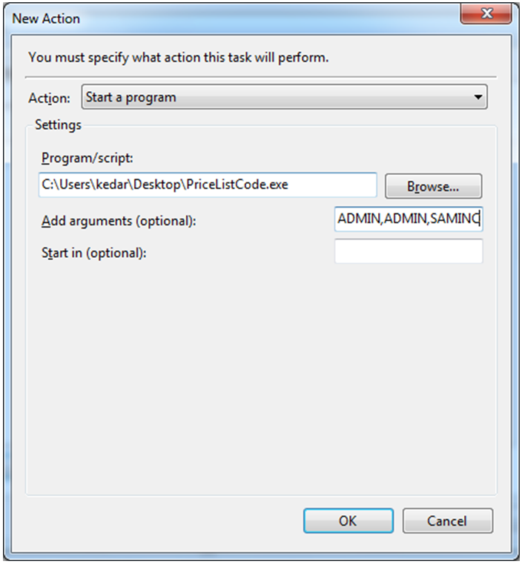](http://www.greytrix.com/blogs/sageaccpacerp/wp-content/uploads/2013/08/3.-New-Action.png)

**g)**In ‘Program/Script’, select BOT BAT file, for which you want to execute using the Browse button.  
**h)** In ‘Add arguments (optional)’ field User Id, Password, and Company Name.  Separate these fields by comma (ADMIN,ADMIN,SAMINC)  
**i)** Click on OK >> ‘New Action’ UI will get closed.  
**j)** Now, navigate to Triggers Tab >> New >> ‘New Trigger’; an UI will get opened.  
**k)** Add a scheduler to run the EXE.

[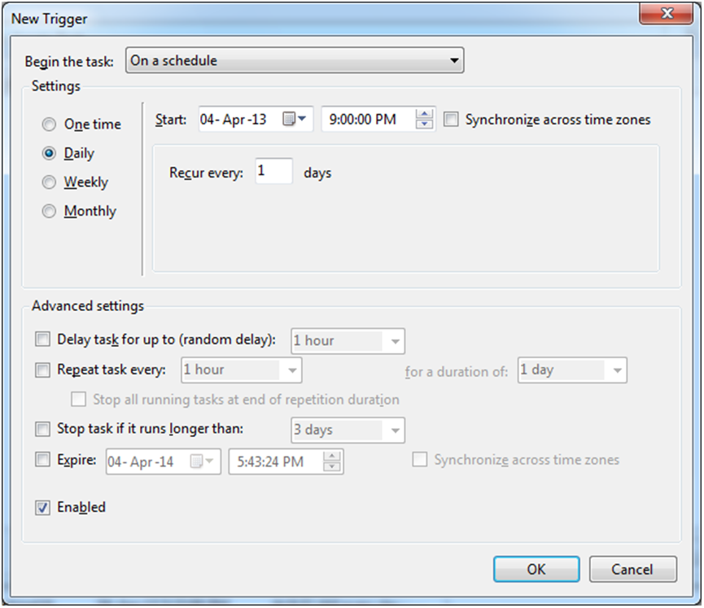](http://www.greytrix.com/blogs/sageaccpacerp/wp-content/uploads/2013/08/4.-New-Trigger.png)

**l)** Click on OK >> New Trigger UI will get closed.  
**m)** Now click on OK button in ‘Create Task’ UI.  
**n)** A pop up will get opened asking for System User Id and Password. Enter details and click on OK.(Optional popup)

This way, the BOT file will run on a daily basis as set in windows scheduler.